Instructions
Be sure to follow strictly the naming conventions (users, groups, folders, files, etc.) specified in the tasks checklist.
Tasks execution order should not be derived from the order in which they are listed below. However, please note that there are tasks that depend on the successful completion of one or more other tasks.
Usually, all steps could be achieved following different paths and using different tools. In the end, not the means, but the end results are being measured.
All changes should remain there after system reboot. For example, new file systems should be mounted also in /etc/fstab. The same applies for all services - they should be operational after system reboot.
Please note that the /data folder and all its sub-folders do not exist (on both VMs), thus you must create them.
Note also, that if a utility like tar, xz, or any other, needed for the successful completion of the tasks is missing, then you are expected to install it.
And one last reminder, you MUST use the exam user to execute the tasks. Should you need administrative access, use the sudo command (no password will be required).

Machines
In general, your virtual infrastructure looks like this:
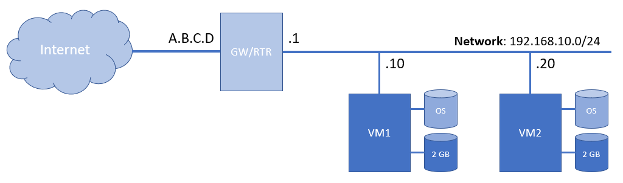
Your external public IP address (A.B.C.D) is 45.66.47.116 . You must combine it with the ports bellow to access the individual virtual machines.
Additional information about the virtual machines can be found here:
# | Distribution | Status | Forwarded Ports
VM 1 | AlmaLinux 10.x | Running | SSH: 10001 -> 22
VM 2 | AlmaLinux 10.x | Running | SSH: 10002 -> 22

Credentials
Password is set to OrangeComputer-6 for the exam user. It has sudo privileges and won't ask for password.
In order to log in to the VM1, you must execute: ssh -p 10001 exam@45.66.47.116 and use the above password.
In order to log in to the VM2, you must execute: ssh -p 10002 exam@45.66.47.116 and use the above password.

Tasks
Please note that you can check if you have completed a task successfully or not by clicking on its number (it is an active link).

Disks and File Systems - 9 tasks, 13 pts
- (T101, 2 pts) [OK] VM1: Use the appropriate tool to create a new primary partition using the MBR partitioning scheme on the smaller (2 GB) and empty hard disk drive with size of 500 MB and type set to Linux LVM
- (T102, 1 pts) [OK] VM1: Create a physical volume on the new partition, created earlier
- (T103, 1 pts) [OK] VM1: Create a volume group named vg_exam on the new physical volume
- (T104, 1 pts) [OK] VM1: Create a logical volume named lv_exam on the new volume group (use 100% of the available space in the volume group)
- (T105, 1 pts) [OK] VM1: Create an xfs file system on the lv_exam logical volume
- (T106, 2 pts) [OK] VM1: Mount the new file system on the /data/xfs folder and add a record in the /etc/fstab file
- (T107, 2 pts) [OK] VM2: Use the appropriate tool to create a new partition using the MBR partitioning scheme on the smaller (2 GB) and empty hard drive with size of 850 MB and type set to Linux Filesystem
- (T108, 1 pts) [OK] VM2: Create ext4 file system on the new partition
- (T109, 2 pts) [OK] VM2: Mount the new file system on the /data/ext4 folder and add a record in the /etc/fstab file

Directories and Files - 9 tasks, 14 pts
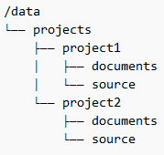
- (T201, 2 pts) [OK] VM1: Create series of directories under the path /data/projects with the following structure (refer to the image)
- (T202, 1 pts) [OK] VM1: In each folder documents from the previous step create an text file named readme.txt that contains the text kernel
- (T203, 1 pts) [OK] VM1: In each folder source create a file named code.sh that contains just the signature for bash scripts and a single command find
- (T204, 2 pts) [OK] VM1: Create a file named unique-animals.txt in the folder /data/animals that contains the sorted list in reverse order of the unique animals (just their names) found in the /important/animal-stories.txt file
- (T205, 1 pts) [OK] VM1: Create a xz compressed archive named important-bak.tar.xz of the /important folder and its content and store it in the /data/archive folder
- (T206, 2 pts) [OK] VM2: Create a text file exam-files.txt (and store it under /data/find folder) that contains the sorted (in ascending order) list of all the places (full path, including the name) where files with exam.lsa name are found
- (T207, 1 pts) [OK] VM2: Create a new file based on the exam-files.txt with all words (in the file) exam changed to EXAM and store it as exam-files-upper.txt in the same folder (/data/find)
- (T208, 2 pts) [OK] VM2: Create a copy of the /important/animal-stories.txt file as /data/animals/lions.txt file which contains only lines that contain the lion text no matter the register (size of the letters) or position in a sentence
- (T209, 2 pts) [OK] VM2: Create a copy of the /important/animal-stories.txt file as /data/animals/colors.txt file which contains only the unique colors in alphabetic order for all records about dogs

Users and Permissions - 8 tasks, 13 pts
- (T301, 2 pts) [OK] VM1: Create a user john with full name John Smith, with some password and auto-created home folder
- (T302, 2 pts) [OK] VM1: Create a user tracy with full name Tracy Parker, with some password and auto-created home folder
- (T303, 1 pts) [OK] VM1: Create a group named gurus
- (T304, 1 pts) [OK] VM1: Make both users, john and tracy, part of the gurus group
- (T305, 1 pts) [OK] VM1: Make user john and group gurus owners of the /data/projects folder and all its sub-folders and files
- (T306, 2 pts) [OK] VM2: Create a user jim with full name Jim Beam, with some password and auto-created home folder
- (T307, 2 pts) [OK] VM2: Create a group named powerteam with group ID set to 2300
- (T308, 2 pts) [OK] VM2: Make the user jim part of the powerteam group

Software and Services - 7 tasks, 9 pts
- (T401, 1 pts) [OK] VM1: Visit https://repos.zahariev.pro/ and follow the instructions to register the repository on the machine
- (T402, 2 pts) [OK] VM1: Create a file /data/repos/packages.txt with the list of all available packages in the repository registered in T401
- (T403, 1 pts) [OK] VM1: Install the hello-lsa package from the repository registered in T401
- (T404, 1 pts) [OK] VM2: Install NGINX Web Server, start it, and enable it to run on boot
- (T405, 1 pts) [OK] VM2: Install the cowsay package and execute it with the following command cowsay 'Hello LSA(3)' > ~/cowsay.txt
- (T406, 1 pts) [OK] VM2: Download the appropriate package for your distribution in the home folder of the exam user:
o For Red Hat-based and openSUSE-based distributions, download: https://zahariev.pro/linux/hello-lsa/releases/hello-lsa-1.0-1.el8.x86_64.rpm
o For Debian-based distributions, download: https://zahariev.pro/linux/hello-lsa/releases/hello-lsa-1.0_amd64.deb
- (T407, 2 pts) [OK] VM2: Install the downloaded package (do not delete the downloaded file)

Scripting and Schedules - 7 tasks, 11 pts
- (T501, 1 pts) [OK] VM1: Create a bash script file (should contain signature at least) named processes.sh in the /data/scripts folder
- (T502, 1 pts) [OK] VM1: Change permissions of the /data/scripts/processes.sh file to executable for everyone
- (T503, 3 pts) [OK] VM1: When executed the processes.sh script should capture the date and time and the number of running processes and store (append) the results in the /tmp/processes.log file.
For example, if the script is executed on 2026.04.19 at 10:15:53 and there are 82 processes, the row that would be stored in the file should be 2026.04.19 10.15.53 -> 82
- (T504, 1 pts) [OK] VM1: Schedule the script for the exam user to execute every five minutes
- (T505, 1 pts) [OK] VM2: Create a bash script file (should contain signature at least) named symbols.sh in the /data/scripts folder
- (T506, 1 pts) [OK] VM2: Change permissions of the /data/scripts/symbols.sh file to executable for everyone
- (T507, 3 pts) [OK] VM2: When executed the symbols.sh script should accept one parameter (if not given, should return an error and exit) and print the symbol * in a row as many times as specified by the parameter.
For example, if the script is executed like this /data/scripts/symbols.sh 4 then the result will be ****

© 2021 - 2026 | Version 2026.04 | Generated on 2026-04-19-09-00-05 (3)

